**LIC DATABASE MANAGEMENT**

LIC database management system will help both customers and their agents to know about the current policies and enabling customers to select policies as per their choice. To start this projects, users have to just run the project and its user friendly menu items will help both its customers and agents to handle this LIC database management system easily. Whenever you run the program, it will start with loading screen as below:

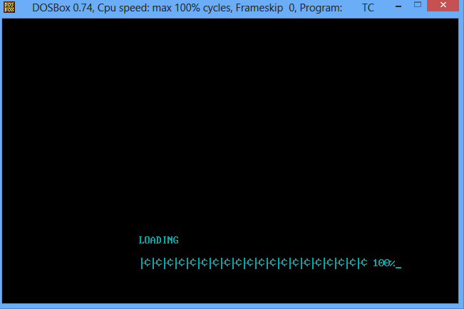

Whenever loading completes, the next screen will be the LIC welcome screen where they are given choice to select the correct options as per their need.

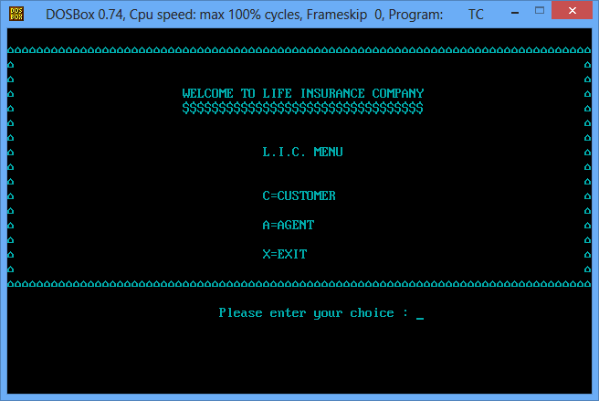

If you want to go the customer section then you have to select its option and if you want to be logged in as agent of LIC then you have been provided with other option. These options are entered at the current cursor position and after which its screen will be appear, where they will required to enter their id to use their particular account. Existing customers will able to check their policy details under which they have made investment.

**Existing System:**

Existing system do not provide facility to select the particular policy by going through each policy details. Customers has to be dependent on agent to get details on particular policy. While taking any particular policy, customers do not able to get information what will be the minimum installment to be made and in what mode. Agent are also not able to check their account any time as per their requirement and the details of customers who have taken policy from them along with their policy maturity date. The present system do not provide the correct medium for the agents to know their commissions which has been made while selling any particular policy. Also the present system do not uses the concept of OOP’S by which changes can be made easily to any particular section within the program code easily.

**Proposed System:**

The current system stored all data in particular file in the binary format which is not able to read by others. Its command prompt will not able its users to know about the background details thus providing the feature of extra security and reliability. Customers will have the option to review any policy as per their choice and select particular policy if they like it. Each customers and agent will have unique id by which they will able to check their account at any time.

Customer Menu details:

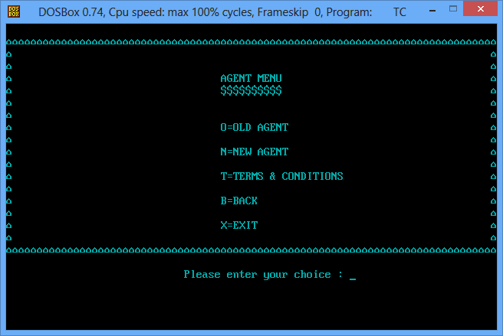

Agent Menu details:



Login Credentials:

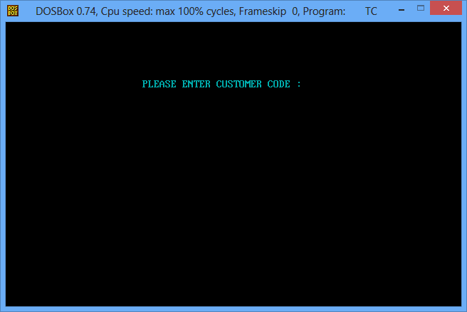

Policy details:

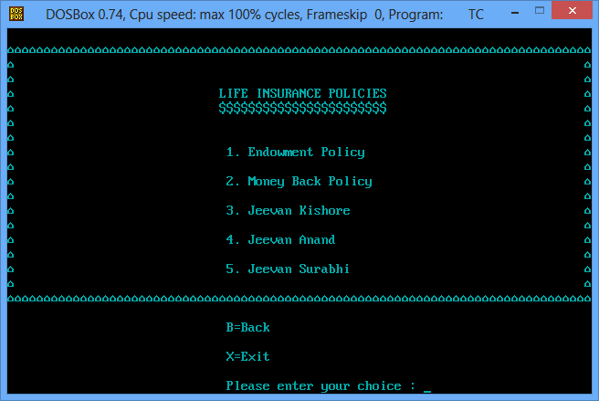

Form fill up process:

